**CLIENT LOGIN:**

**LOGIN PAGE**



**Welcome to the Function Booking section of Manly Deck Bar & Restaurant!**

We offer you the exclusive and fun setting of our Deck Area for your function. Our Deck Area has the capacity to host 80-100 guests at a time. If you are expecting more guests, you can contact us at **33963824** or [**info@manlydeck.com.au**](mailto:info@manlydeck.com.au)to book the complete restaurant! Else, this portal will help you with the booking!

In this portal you can do the following:

* Choose the date and time for your function and book our Deck Area through Online Payment
* Order Hot & Cold Food Platters for your function after booking the Deck Area
* If you are not sure what food you want to order for the function, go ahead and book only the Deck Area now. Come back at a later date (not later than 7 days before the function) and order your Food Platters here. You can also select your Food Platters now and come back to place the order at a later date.

**NOTE:**

If you prefer a **2-course/3-course meal** or a **Buffet** for the function, then please contact us directly at **33963824** or **info@manlydeck.com.au** after booking the Deck Area.

***DESCRIPTION***

LOGIN HERE

***FIELDS:***

Email

Password

***BUTTONS***

Login

New User? Register

Forgot Password?

***POP-UP on REGISTER***

**Wrong username or password:**

Please check the Username & Password!

**Register Window – new user registration**

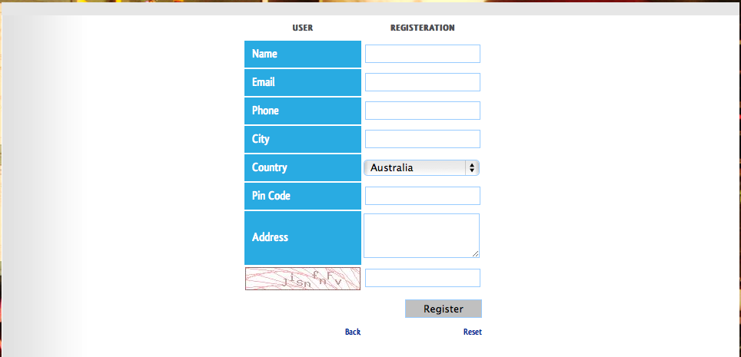

***DESCRIPTION***

NEW USER REGISTRATION

***FIELDS***

Name

Email

Phone

City

Postcode

Address

***BUTTON***

Register

Back

Reset (to be moved against captcha code and tested for functionality)

***POP-UP on REGISTER***

**For empty ‘Name’:**

Please fill ‘Name’!

**For empty ‘Email’:**

Please fill ‘Email!

**For empty ‘Phone’:**

Please fill ‘Phone’!

**For empty ‘City’:**

Please fill ‘City’!

**For empty ‘Postcode’:**

Please fill ‘Postcode’!

**For empty ‘Address’:**

Please fill ‘Address’!

**For empty ‘Captcha’:**

Please fill ‘Captcha Code’!

**For Invalid Mail id :**

Please provide a valid Email Id!

**For Incorrect Captcha :**

Incorrect Captcha! Please try again.

**On registration:**

Your account has been successfully created! You would have received an Email with a link to activate your account.

**ACTIVATION PAGE**

**On click of activation link:**

Your account has now been activated! Please login and proceed to book your function.

**FORGOTTEN PASSWORD**



***DESCRIPTION***

Enter the Email Id used for Login

***FIELDS***

Email

***BUTTON***

Submit

***POP-UP on SUBMIT***

**For success :**

Your Password has been mailed to your Email Id.

**For failure :**

We were unable to mail you your Password.

**Please contact us at 33963824 or** [**info@manlydeck.com.au**](mailto:info@manlydeck.com.au) **.**

**DEFAULT PAGE:**

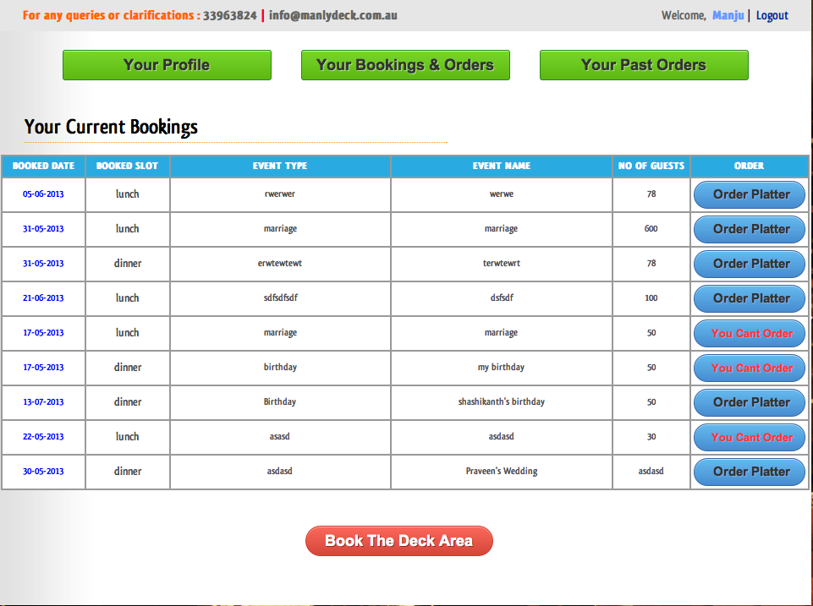

***GREEN BUTTON 1:***

YOUR PROFILE

***GREEN BUTTON 2:***

FUNCTION BOOKINGS

***GREEN BUTTON 3:***

PLATTER ORDER HISTORY

**YOUR PROFILE page:**

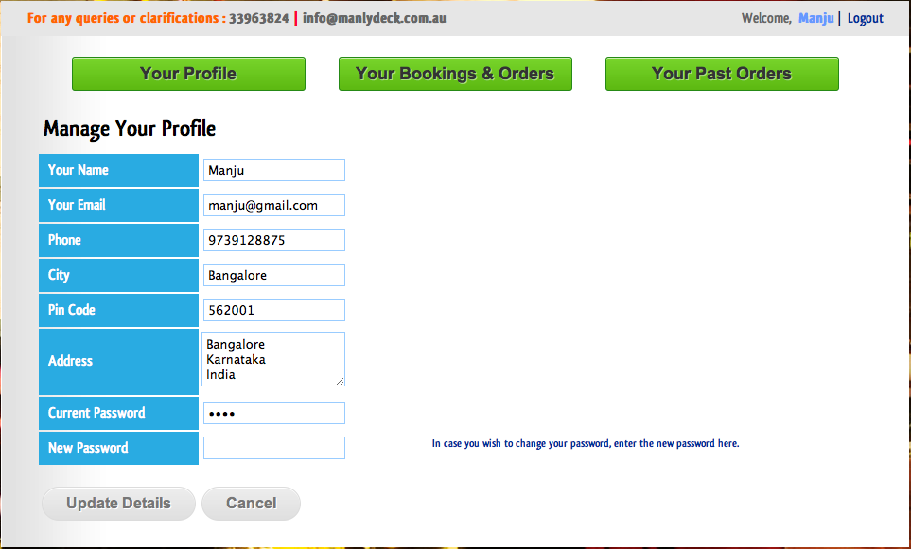

***DESCRIPTION***

YOUR PROFILE Manage your Profile

***FIELDS:***

Name

Email

Phone

City

Postcode

Address

Current Password

New Password (tool tip: If you wish to change your password, please fill in your new password here.)

***BUTTONS***

Update

Cancel

***POP-UP on SAVE***

Profile successfully updated!

Profile update failed! Please try again after logging in again. In case of repeated failure, please contact us at info@manlydeck.com.au.

**FUNCTION BOOKINGS page**



***DESCRIPTION***

FUNCTION BOOKINGS Your Deck Area bookings & history

***EMPTY PAGE***

You have no Bookings currently!

***TABLE FIELDS***

Function Date

Time

Function Type

Function Name

No. of Guests

Food Platters

***BUTTONS***

ORDER PLATTERS {tool tip (in case of expired or disabled order): This Platter Order is for a function of past date or you are trying to order for a function that is within 7 days from today. For last minute Platter orders please contact the restaurant directly at **33963824**.}

Book DECK AREA for NEW FUNCTION

**PLATTER ORDER HISTORY page**

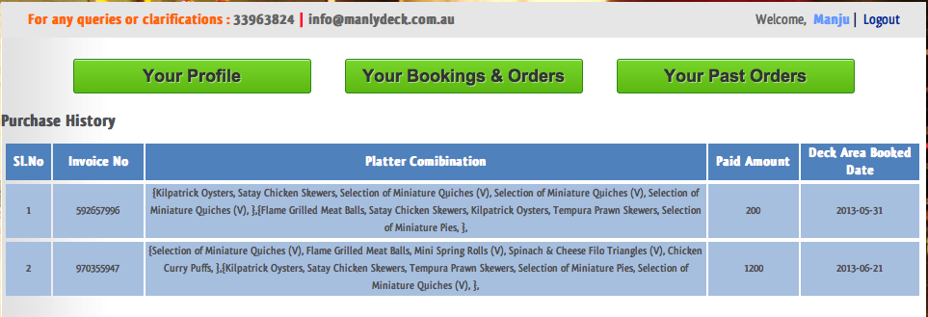

***DESCRIPTION***

PLATTER ORDER HISTORY Your paid Platters

***EMPTY PAGE***

You have no Platter Orders currently!

***TABLE FIELDS***

Sl. No.

Function Date

Platters Ordered

***FORMAT OF PLATTERS DISPLAY IN PLATTERS ORDERED FIELD***

{Kilpatrick Oysters, Satay Chicken Skewers, Selection of Miniature Quiches (V), Selection of Miniature Quiches (V), Selection of Miniature Quiches (V)} – 1

{Flame Grilled Meat Balls, Satay Chicken Skewers, Kilpatrick Oysters, Tempura Prawn Skewers, Selection of Miniature Pies} - 4

**DECK AREA BOOKING – date selection page**

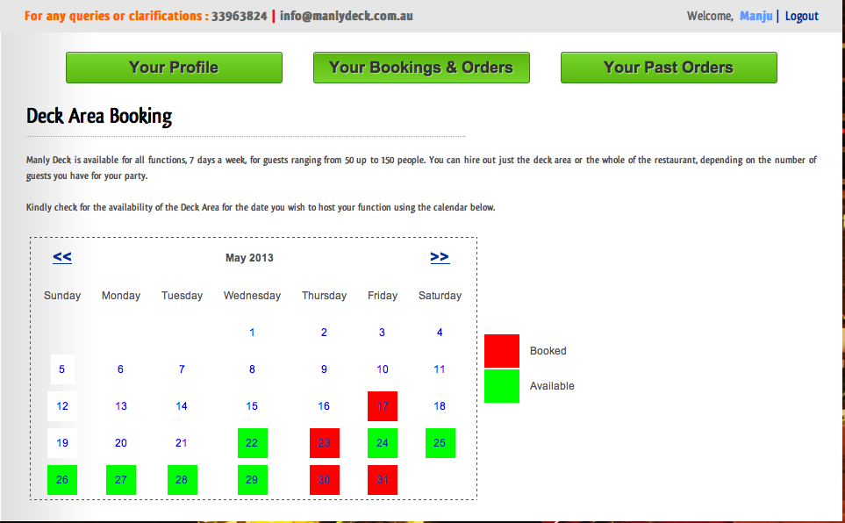

***DESCRIPTION***

FUNCTION BOOKINGS Select your Function Date

***WRITE UP***

Our Deck Area has the capacity to host 80-100 guests at a time. If you are expecting more guests, please contact us at **33963824** or [**info@manlydeck.com.au**](mailto:info@manlydeck.com.au)to book the complete restaurant!

Kindly use the calendar below to check for availability of Deck Area for your function. The color code next to the calendar will help you.

***COLOR CODES***

Lunch slot available

Dinner slot available

Both slots available

Both slots booked

***DATE SELECTION FIELD***

Select Function Date

***BUTTON***

Book Deck Area

**DECK AREA BOOKING – booking details page**

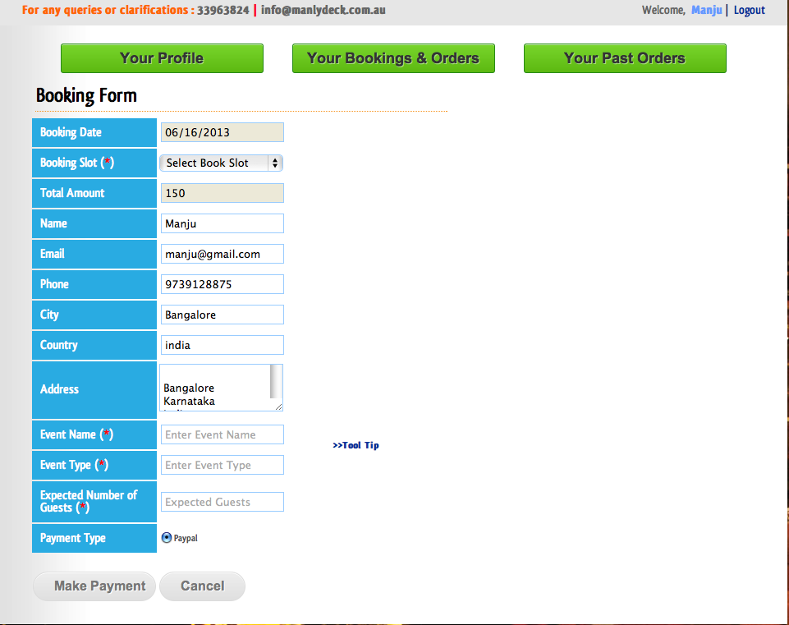

***DESCRIPTION***

BOOKING DETAILS Fill in your Function Details

***FIELDS***

Function Date

Time of Day (hint: Select Slot)

[Change pull down to:

Lunch (11:30 am to 3:30 pm)

Dinner (4:30 pm to Midnight)

]

Deck Area Rent (in $)

Name

Email

Phone

City

Address

Function Name (hint: e.g. Bob’s Birthday)

Function Type (hint: e.g. 21st Birthday Party) (Tooltip: If your function is an *18th or 21st Birthday Party, you will have to pay a $50/hour (min 4 hours) charge for Security Service at the Restaurant in Cash.)*

Expected No. of Guests (hint: e.g. 50-60)

Payment Type (Paypal/Credit Card)

***BUTTONS***

MAKE PAYMENT

CANCEL

***POP-UP on MAKE PAYMENT***

**For empty ‘Time of Day’:**

Please select ‘Time of Day’!

**For empty ‘Function Name’:**

Please fill ‘Function Name’!

**For empty ‘Function Type’:**

Please fill ‘Function Type’!

**For empty ‘Expected No. of Guests’:**

Please fill ‘Expected No. of Guests’!

**SUCCESS PAGE – success message**

***SUCCESS MESSAGE***

Your Payment has been processed successfully!

Your booking for ___(Function Name) on ____(Function Date) is confirmed! You will receive a mail regarding the same.

You can now proceed to select Food Platters for your function by clicking on the button shown below.

OR

You can choose to select your Platters at a later date through the ORDER PLATTERS button shown against the Function Date in the FUNCTION BOOKINGS page.

***FAILURE MESSAGE***

Sorry, but processing of your Payment has failed!

**Please contact us at 33963824 or** [**info@manlydeck.com.au**](mailto:info@manlydeck.com.au) **.**

***BUTTON***

CLICK TO ORDER PLATTERS

**PLATTER SELECTION – introduction page**

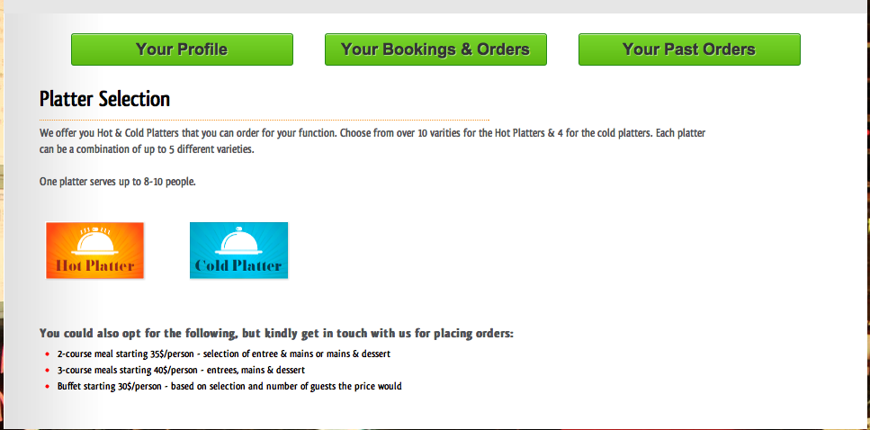

***DESCRIPTION***

PLATTER SELECTION Pick your Food Platters

***WRITE UP***

You can order Hot & Cold Platters for your function at Manly Deck. You can order any number of Platters, each Platter having a combination of up to 5 items.

One platter serves about 8-10 people. So go ahead and pick what you want to treat your guests to!!

Please note:

* Your Platter selections will be saved in our system till 7 days before the function date. So you can choose your Platter combinations over multiple logins before placing an order.
* You will be allowed to order Platters through this portal only till 7 days before the function date. Any order after that has to be over phone to 33963824 and will be taken up only at the discretion of the restaurant. So please ensure that you select and pay for your Platters well before that.

**If you prefer to go for a 2-course/3-course meal or a Buffet, then contact us at 33963824 or** [**info@manlydeck.com.au**](mailto:info@manlydeck.com.au) **.**

***BUTTONS***

SELECT PLATTER COMBINATIONS

**PLATTER SELECTION – selection page**

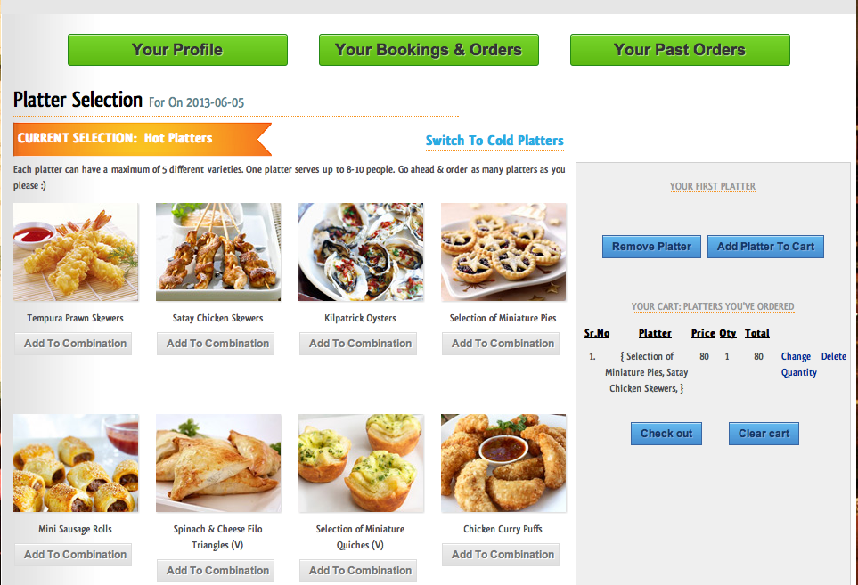

***DESCRIPTION***

PLATTER SELECTION For ___(Function Name) on __(Function Date)

***HEADER***

ITEMS for: HOT PLATTERS

See ITEMS for COLD PLATTERS

ITEMS for: COLD PLATTERS

See ITEMS for HOT PLATTERS

***WRITE UP***

You can order any number of Hot & Cold Platters, each Platter having a combination of up to 5 items. Each Platter feeds about 8-10 people!

Select Items for your Platter from our listing and then add each Platter to the Cart. Once you have all the Platters you need, proceed to order. Happy ordering!!

***BUTTON HEADINGS***

Platter Combination

Your Cart: Platters you’ve ordered

***BUTTONS***

**Below each Item:**

ADD TO PLATTER

**In Cart:**

CLEAR PLATTER

ADD PLATTER TO CART

CLEAR CART

ORDER

**Small Buttons:**

Modify Quantity

Delete

***TABLE FIELDS***

Sl. No.

Platter

Price ($)

Qty

Total ($)

***POP-UPs***

**Adding more than 5 to Platter:**

You can have a maximum of only 5 Items in a Platter!

**Mixing of Hot & Cold Items:**

You cannot mix Hot & Cold Items in a single Platter! Please order separate Platters!

**Platter Added to Cart:**

Your Platter has been successfully added to the Cart! You can add more Platters to your Cart or modify quantity of already added Platters!

**Delete of item from Cart:**

Are you sure that you want to delete this Platter from your Cart?

**Click of Clear Platter when Platter Combo is empty:**

There are no Items in the Platter!

**Click of Add Platter to cart when Platter Combo is empty:**

There is no Platter to add!

**Clear Cart:**

Are you sure that you want to clear all Platters from your Cart?

**Click of Clear Cart when Cart is empty:**

There are no Platters in the Cart!

**PLATTER QUANTITY CHANGE – quantity modification page**

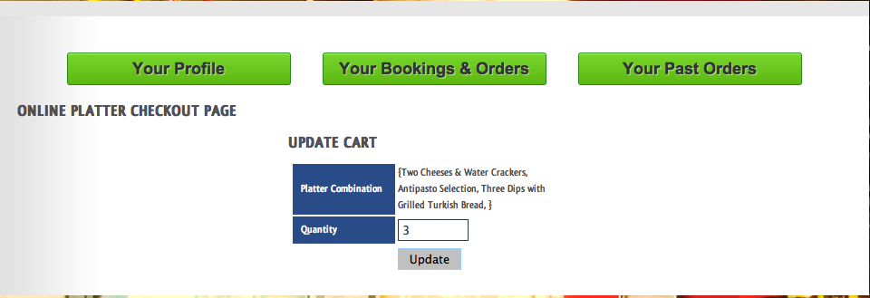

***DESCRIPTION***

MODIFY PLATTER QUANTITY

***FIELDS HEADING***

PLATTER DETAILS

***FIELDS***

Platter Combination

Quantity

***BUTTON***

MODIFY

**PLATTER CHECKOUT – check out page**

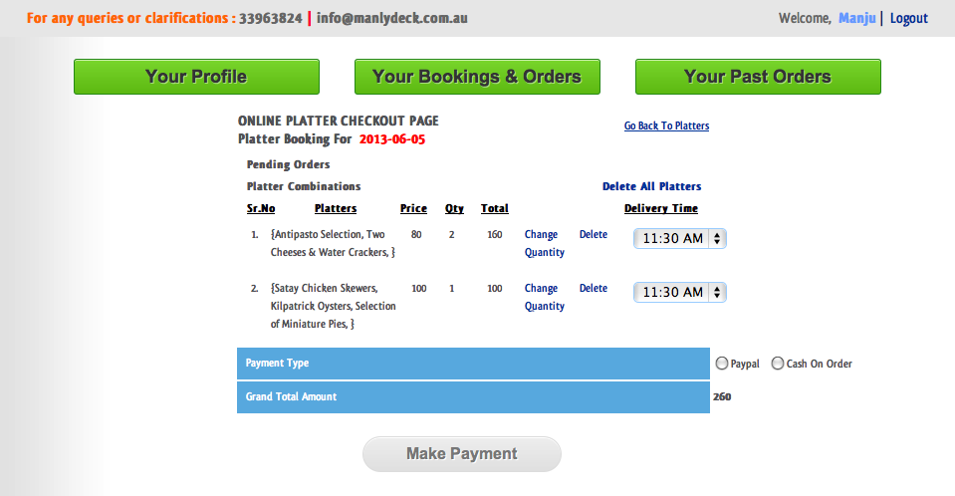

***DESCRIPTION***

PLATTER ORDER CHECKOUT

***HEADING***

Platter Order for ___(function name) on _____(function date)

Delete these headings and links:

|  |
| --- |
| **Pending Orders** |
| **Platter Combinations**  **Delete all Platters** |

***TABLE FIELDS***

Sl. No.

Platters

Price (in $)

Qty

Total (in $)

Serve Platter at

***OTHER FIELDS***

Payment Type (Paypal/Credit Card Cash at Restaurant)

Grand Total (in $)

***BUTTONS***

**Link to go back to Cart:**

Go Back to Platter Selection

**Small Buttons:**

Modify Quantity

Delete

***POP-UPs***

**Delete of platter from Cart:**

Are you sure that you want to delete this Platter from your Cart?

**Unselected Payment type**

Please select ‘Payment Type’!

***BUTTON***

MAKE PAYMENT

**CASH AT RESTAURANT SUCCESS – check out success page**

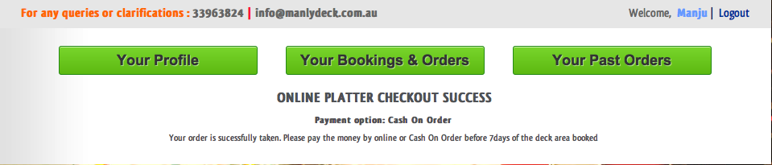

***SUCCESS MESSAGE***

YOUR PLATTER ORDER HAS BEEN SUCCESSFULLY PROCESSED!

Payment Type: Cash at Restaurant

Your Platter Order for ___(Function Name) on ____(Function Date) is processed! You will receive a mail regarding the same.

**ATTENTION!!**

Your Platter Order will be saved in our system till 7 days before the function date. You will need to pay the amount at the Restaurant not later than 7 days from the date of the function. Else, the order will only be taken up at the discretion of the Restaurant. So please ensure that you pay for your Platters well before that.

***FAILURE MESSAGE***

SORRY, BUT PROCESSING OF YOUR PLATTER ORDER HAS FAILED!

**Please contact us at 33963824 or** [**info@manlydeck.com.au**](mailto:info@manlydeck.com.au) **.**

**PAYPAL SUCCESS – check out success page**

***SUCCESS MESSAGE***

PAYMENT FOR PLATTER ORDER HAS BEEN SUCCESSFULLY PROCESSED!

Your Platter Order for ___(Function Name) on ____(Function Date) is confirmed! You will receive a mail regarding the same.

***FAILURE MESSAGE***

SORRY, BUT PROCESSING OF YOUR PAYMENT FOR THE PLATTER ORDER HAS FAILED!

**Please contact us at 33963824 or** [**info@manlydeck.com.au**](mailto:info@manlydeck.com.au) **.**

**ADMIN LOGIN:**

**CATEGORY SELECTION – option selection page**

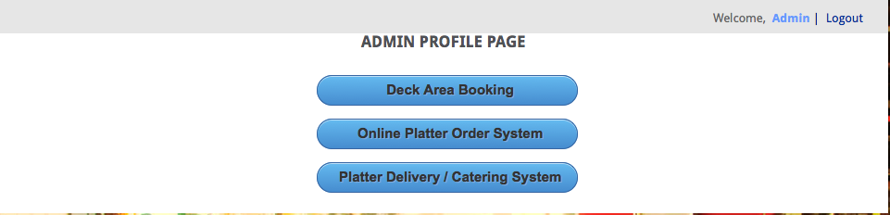

***DESCRIPTION***

WHAT DO YOU WANT TO MANAGE

***BUTTONS***

DECK AREA BOOKINGS

DECK AREA PLATTER ORDERS

PLATTER DELIVERIES

**DECK AREA BOOKINGS– page to manage Function Bookings**

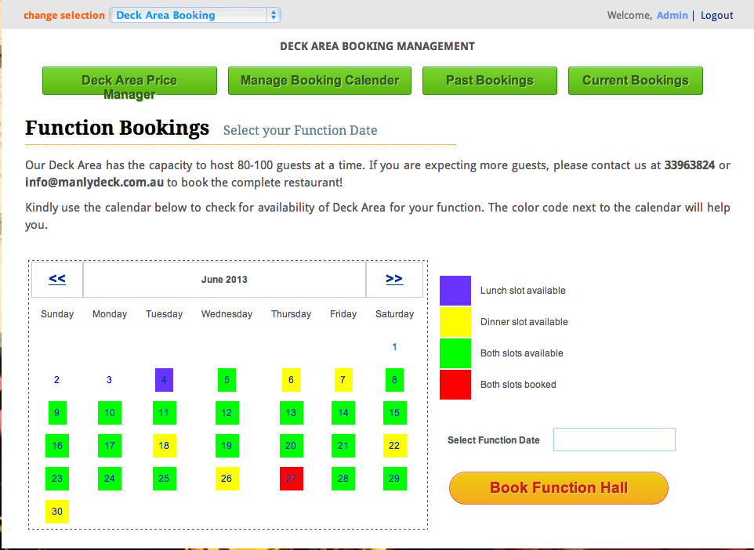

***PAGE HEADING***

DECK AREA BOOKING MANAGEMENT

***DESCRIPTION***

BOOKING CALENDAR View Deck Area availability

***PULL DOWN AT TOP LEFT (in all pages)***

**Description**

Manage

**Pull down options**

DECK AREA BOOKINGS

DECK AREA PLATTER ORDERS

PLATTER DELIVERIES

***BUTTONS IN SECTION***

DECK AREA PRICES

BOOKING CALENDAR

PAST BOOKINGS

CURRENT BOOKINGS

***COLOR CODES***

Lunch slot available

Dinner slot available

Both slots available

Both slots booked

***DATE SELECTION FIELD (display calendar icon so people know there is a calendar selection there)***

Select Function Date

***BUTTON***

Book Deck Area

**FUNCTION DETAILS – page to fill function details**

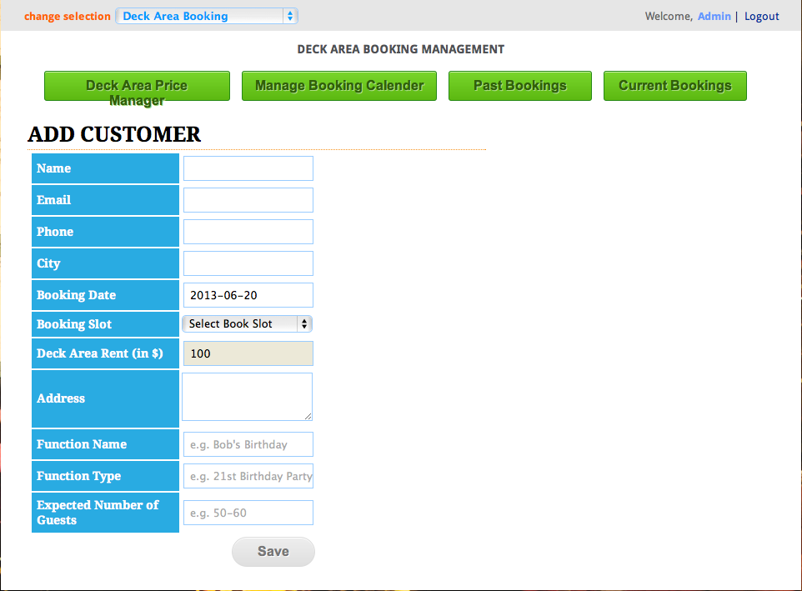

***PAGE HEADING***

DECK AREA BOOKING MANAGEMENT

***DESCRIPTION***

BOOKING DETAILS Fill in Function Details

***BUTTONS IN SECTION***

DECK AREA PRICES

BOOKING CALENDAR

PAST BOOKINGS

CURRENT BOOKINGS

***FIELDS***

Customer Name

Email

Phone

City

Address

Function Date

Time of Day (hint: Select Slot)

[Change pull down to:

Lunch (11:30 am to 3:30 pm)

Dinner (4:30 pm to Midnight)

]

Deck Area Rent (in $)

Function Name (hint: e.g. Bob’s Birthday)

Function Type (hint: e.g. 21st Birthday Party)

Expected No. of Guests (hint: e.g. 50-60)

***BUTTONS***

BOOK

***POP-UP on SAVE***

**For empty ‘Customer Name’:**

Please fill ‘Customer Name’!

**For empty ‘Email’:**

Please fill ‘Email’!

**For empty ‘Phone’:**

Please fill ‘Phone’!

**For empty ‘City’:**

Please fill ‘City’!

**For empty ‘Time of Day’:**

Please select ‘Time of Day’!

**For empty ‘Function Name’:**

Please fill ‘Function Name’!

**For empty ‘Function Type’:**

Please fill ‘Function Type’!

**For empty ‘Expected No. of Guests’:**

Please fill ‘Expected No. of Guests’!

**CURRENT BOOKINGS – page of current function bookings**

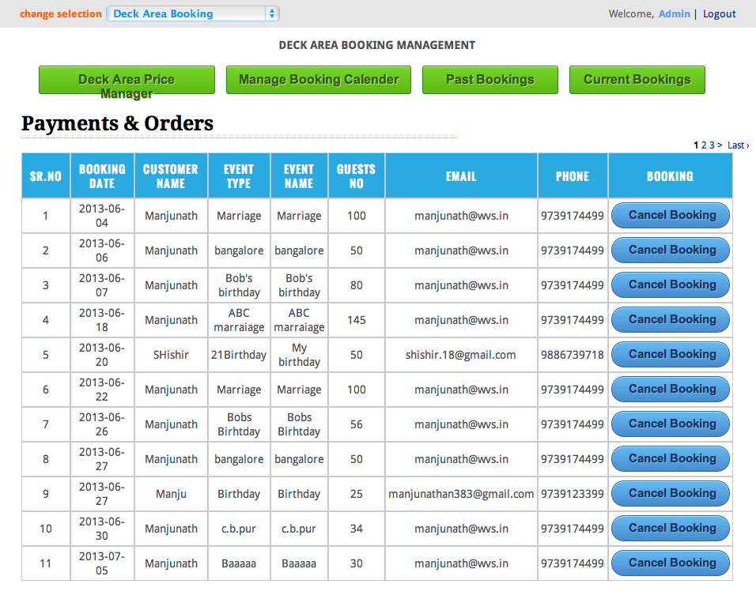

***PAGE HEADING***

DECK AREA BOOKING MANAGEMENT

***DESCRIPTION***

CURRENT BOOKINGS Already booked Functions

***BUTTONS IN SECTION***

DECK AREA PRICES

BOOKING CALENDAR

PAST BOOKINGS

CURRENT BOOKINGS

***TABLE FIELDS***

Sl. No.

Function Date

Time

Function Type

Function Name

No. of Guests

Customer Name

Email

Phone

Booking

***BUTTONS***

CANCEL BOOKING

**CANCEL BOOKING – page for booking cancellation**

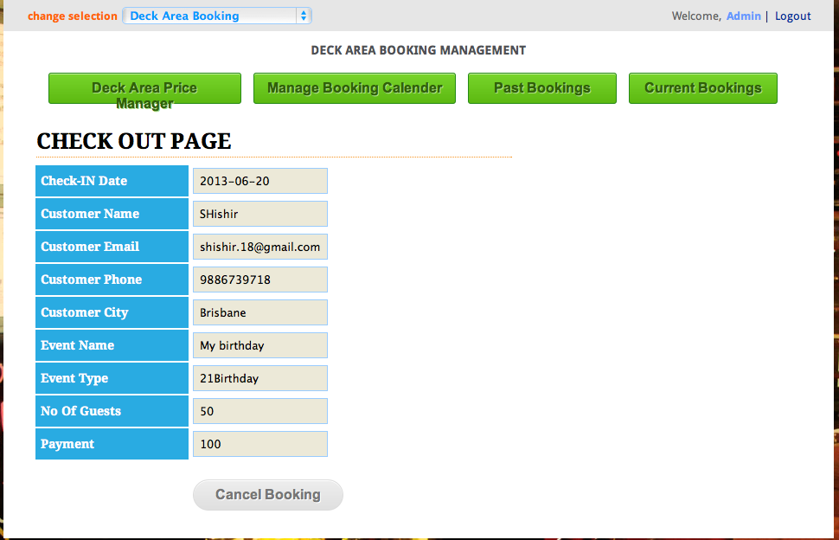

***PAGE HEADING***

DECK AREA BOOKING MANAGEMENT

***DESCRIPTION***

BOOKING CANCELLATION

***BUTTONS IN SECTION***

DECK AREA PRICES

BOOKING CALENDAR

PAST BOOKINGS

CURRENT BOOKINGS

***FIELDS***

Function Date

Time of Day

Function Name

Customer Name

Email

Phone

City

***BUTTONS***

CANCEL BOOKING

**PAST BOOKINGS – page displaying Past Bookings**

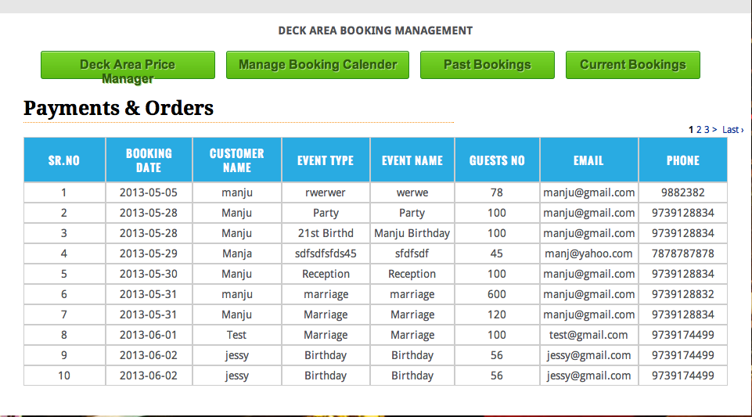

***PAGE HEADING***

DECK AREA BOOKING MANAGEMENT

***DESCRIPTION***

PAST BOOKINGS Bookings of past date

***BUTTONS IN SECTION***

DECK AREA PRICES

BOOKING CALENDAR

PAST BOOKINGS

CURRENT BOOKINGS

***TABLE FIELDS***

Sl. No.

Function Date

Time

Function Type

Function Name

No. of Guests

Customer Name

Email

Phone

**DECK AREA PRICES – page for changing Deck Area prices**

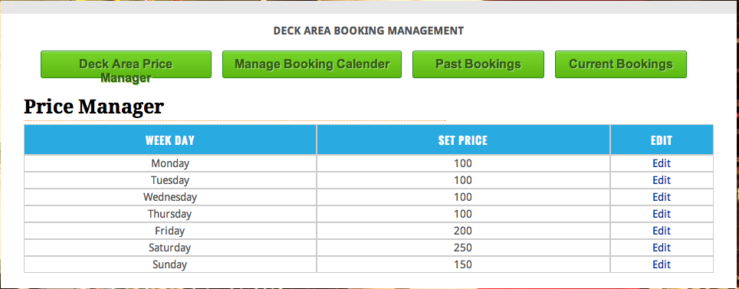

***PAGE HEADING***

DECK AREA BOOKING MANAGEMENT

***DESCRIPTION***

DECK AREA PRICES Deck Area rent for day of week

***BUTTONS IN SECTION***

DECK AREA PRICES

BOOKING CALENDAR

PAST BOOKINGS

CURRENT BOOKINGS

***TABLE FIELDS***

Day of Week

Price

Modify

***BUTTON***

**For modify**

Edit

**PRICE MODIFICATION – page for changing price**

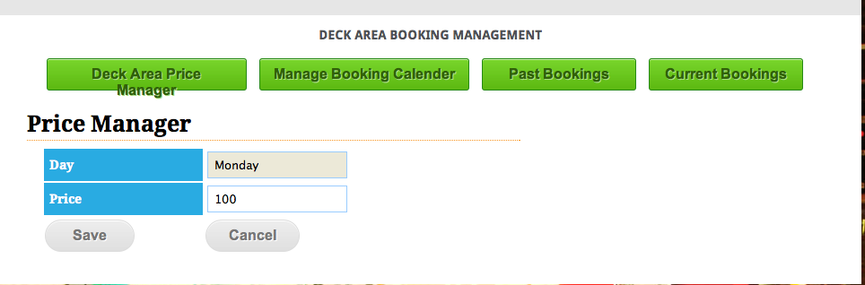

***PAGE HEADING***

DECK AREA BOOKING MANAGEMENT

***DESCRIPTION***

PRICE MANAGER

***BUTTONS IN SECTION***

DECK AREA PRICES

BOOKING CALENDAR

PAST BOOKINGS

CURRENT BOOKINGS

***TEXT FIELDS***

Day of Week

Price

***BUTTON***

SAVE

CANCEL

**DECK AREA PLATTER ORDERS – landing page for Deck Area Platter Orders**

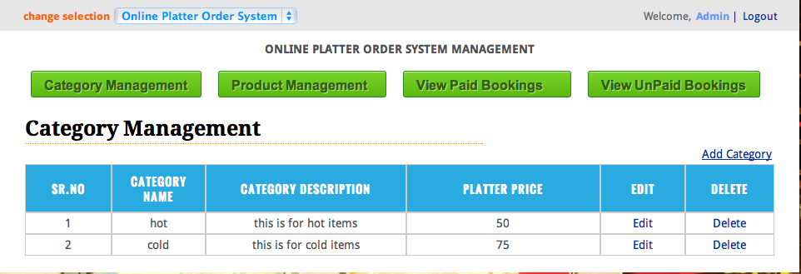

***PAGE HEADING***

DECK AREA PLATTER MANAGEMENT

***DESCRIPTION***

PLATTER CATEGORIES Add/remove/modify Platter Categories

***BUTTONS IN SECTION***

PLATTER CATEGORIES

PLATTER ITEMS

PAID PLATTER ORDERS

UNPAID PLATTER ORDERS

***TABLE FIELDS***

Sl. No.

Category

Category Description

Platter Price

Modify

Delete

***BUTTON***

ADD CATEGORY

MODIFY  
  
DELETE

**PLATTER CATEGORY MODIFY – page to edit Platter Category**

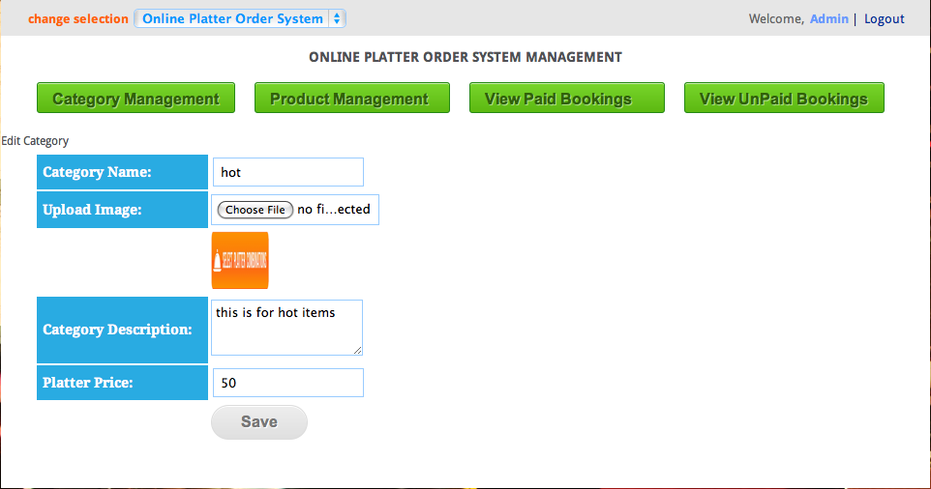

***PAGE HEADING***

DECK AREA PLATTER MANAGEMENT

***DESCRIPTION***

MODIFY PLATTER CATEGORY

***BUTTONS IN SECTION***

PLATTER CATEGORIES

PLATTER ITEMS

PAID PLATTER ORDERS

UNPAID PLATTER ORDERS

***FIELDS***

Category

Category Image

Category Description

Platter Price

***BUTTON***

SAVE

**DELETE PLATTER CATEGORY – action to Delete Platter Category**

***POP UP***

Are you sure that you want to delete this Platter Category?

**ADD PLATTER CATEGORY – page to Add Platter Category**

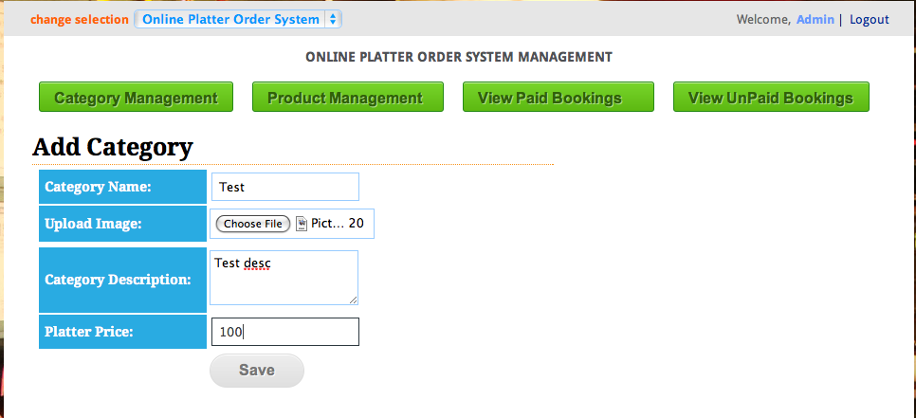

***PAGE HEADING***

DECK AREA PLATTER MANAGEMENT

***DESCRIPTION***

ADD PLATTER CATEGORY

***BUTTONS IN SECTION***

PLATTER CATEGORIES

PLATTER ITEMS

PAID PLATTER ORDERS

UNPAID PLATTER ORDERS

***FIELDS***

Category

Category Image

Category Description

Platter Price

***BUTTON***

SAVE

**PLATTER ITEMS – page to Add Platter Item**

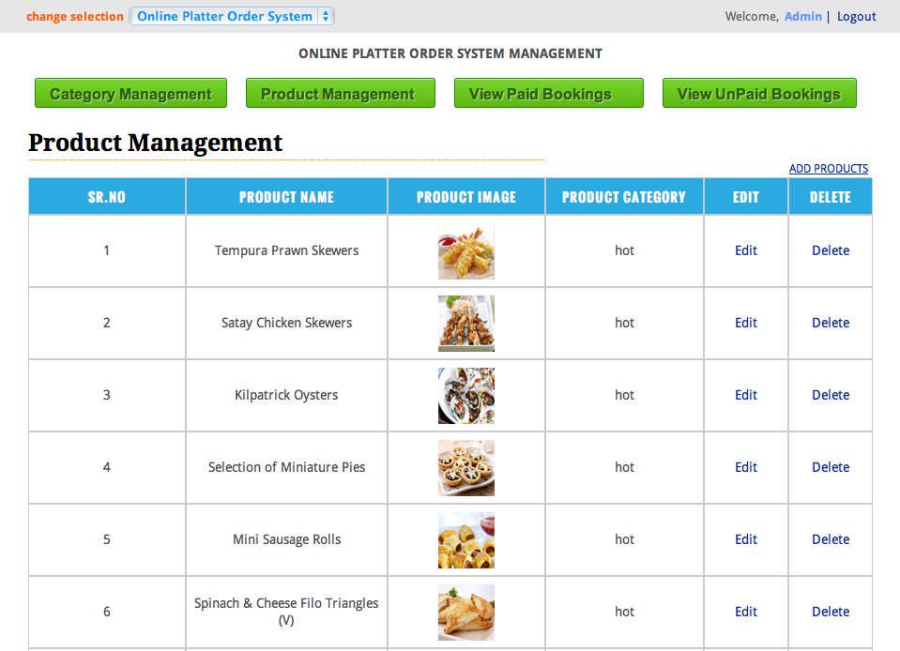

***PAGE HEADING***

DECK AREA PLATTER MANAGEMENT

***DESCRIPTION***

PLATTER ITEMS Add/remove/modify Platter Items

***BUTTONS IN SECTION***

PLATTER CATEGORIES

PLATTER ITEMS

PAID PLATTER ORDERS

UNPAID PLATTER ORDERS

***FIELDS***

Sl. No.

Item Name

Item Image

Platter Category

Modify

Delete

***BUTTON***

ADD ITEM

MODIFY  
  
DELETE

**ITEM MODIFY – page to edit Item**

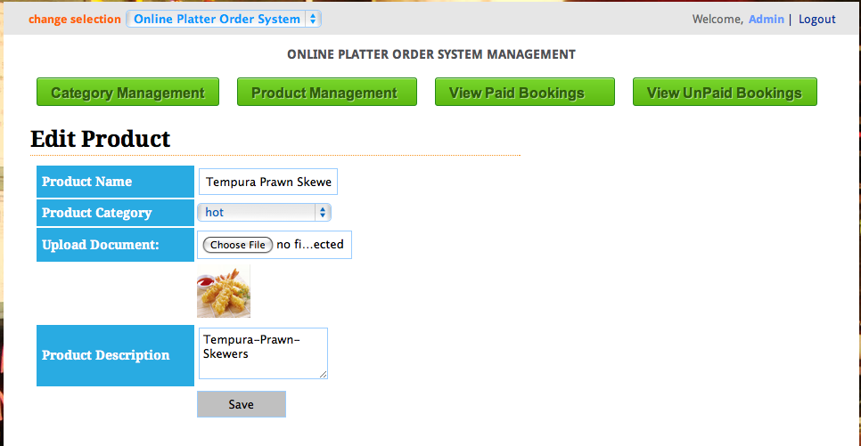

***PAGE HEADING***

DECK AREA PLATTER MANAGEMENT

***DESCRIPTION***

MODIFY PLATTER ITEM

***BUTTONS IN SECTION***

PLATTER CATEGORIES

PLATTER ITEMS

PAID PLATTER ORDERS

UNPAID PLATTER ORDERS

***FIELDS***

Item Name

Item Category [Change pull down to:

Hot

Cold

]

Item Image

Item Description

***BUTTON***

SAVE

**DELETE PLATTER ITEM – action to Delete Platter Item**

***POP UP***

Are you sure that you want to delete this Platter Item?

**ADD PLATTER ITEM – page to Add Platter Category**

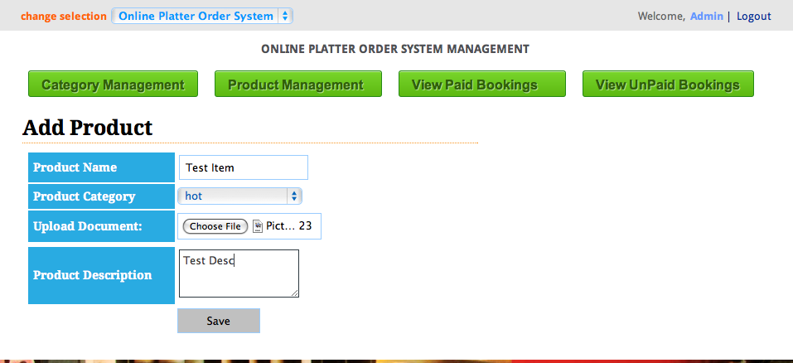

***PAGE HEADING***

DECK AREA PLATTER MANAGEMENT

***DESCRIPTION***

ADD PLATTER ITEM

***BUTTONS IN SECTION***

PLATTER CATEGORIES

PLATTER ITEMS

PAID PLATTER ORDERS

UNPAID PLATTER ORDERS

***FIELDS***

Item Name

Item Category [Change pull down to:

Hot

Cold

]

Item Image

Item Description

***BUTTON***

SAVE

**PAID PLATTER ORDERS – page to view Paid Platters**

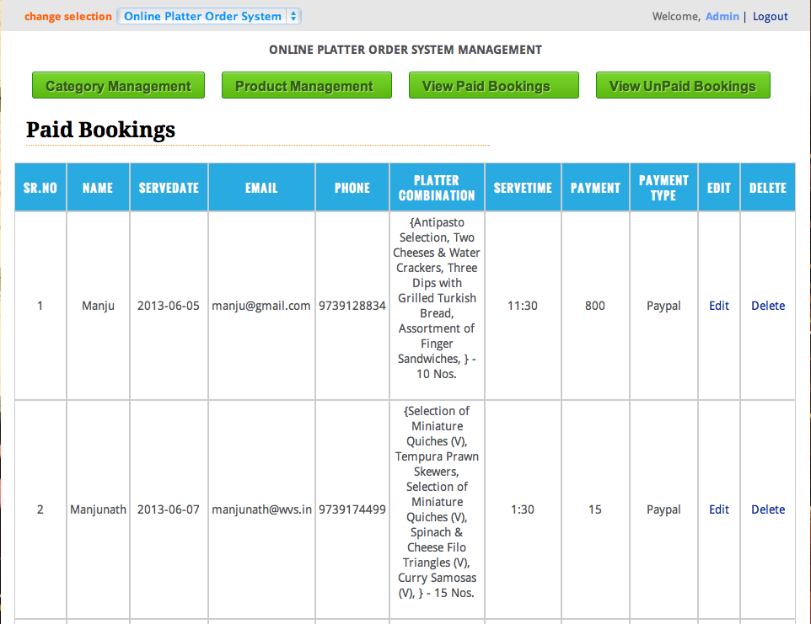

***PAGE HEADING***

DECK AREA PLATTER MANAGEMENT

***DESCRIPTION***

PAID PLATTER ORDERS Listing of Platters already paid for

***BUTTONS IN SECTION***

PLATTER CATEGORIES

PLATTER ITEMS

PAID PLATTER ORDERS

UNPAID PLATTER ORDERS

***TABLE FIELDS***

Sl. No.

Function Date

Platter Order

Serve Time

Customer Details

Payment

Payment Type

Modify

Delete

***BUTTON***

Modify

Delete

***POP UP***

Are you sure that you want to delete this Paid Platter Order?

**UNPAID PLATTER ORDERS – page to view Unpaid Platters**

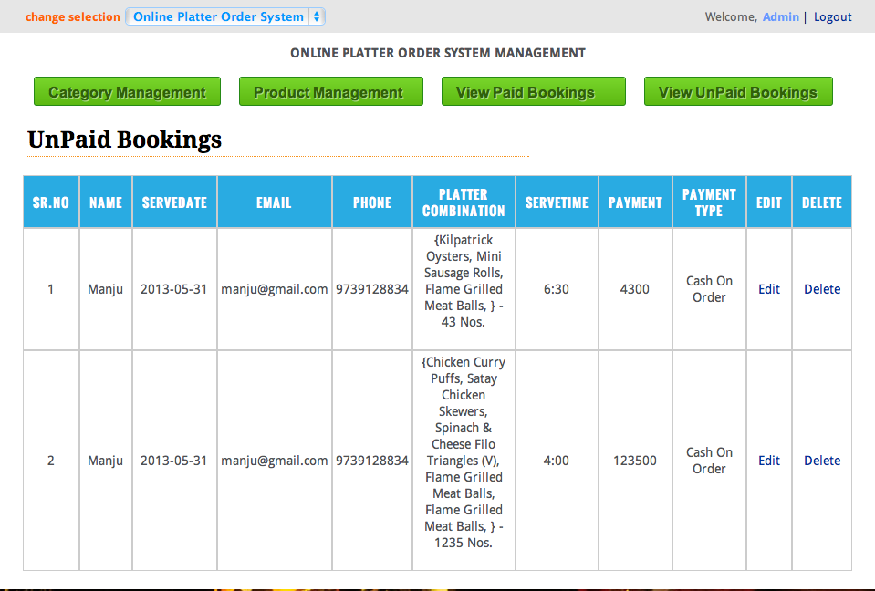

***PAGE HEADING***

DECK AREA PLATTER MANAGEMENT

***DESCRIPTION***

UNPAID PLATTER ORDERS Listing of Platters not paid for

***BUTTONS IN SECTION***

PLATTER CATEGORIES

PLATTER ITEMS

PAID PLATTER ORDERS

UNPAID PLATTER ORDERS

***FIELDS***

Sl. No.

Function Date

Platter Order

Serve Time

Customer Details

Payment

Payment Type

Modify

Delete

***BUTTON***

Modify

Delete

***POP UP***

Are you sure that you want to delete this Unpaid Platter Order?

**UNPAID PLATTER ORDERS Modification – page to Modify Unpaid Platters**

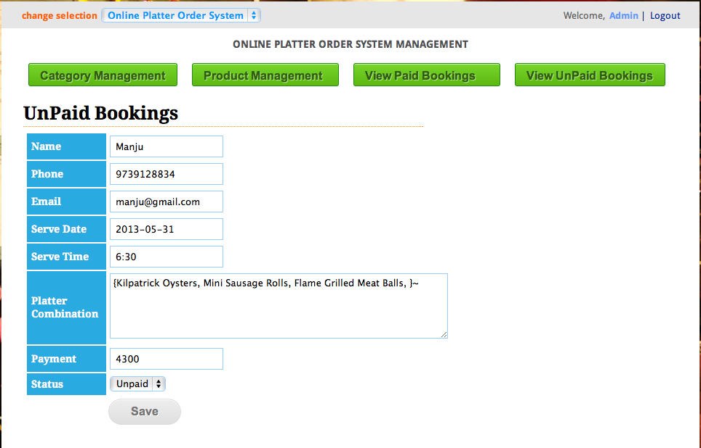

***PAGE HEADING***

DECK AREA PLATTER MANAGEMENT

***DESCRIPTION***

PLATTER ORDER STATUS CHANGE

***BUTTONS IN SECTION***

PLATTER CATEGORIES

PLATTER ITEMS

PAID PLATTER ORDERS

UNPAID PLATTER ORDERS

***FIELDS***

Customer Name

Email

Phone

Function Date

Platter Order

Payment

Payment Status

***BUTTON***

CONFIRM PAYMENT

[Change pull down to:

Paid

Unpaid

]